Employee No. 1253592
FORM 2 (Revised)

NOMINATION AND DECLARATION FORM FOR UNEXEMPTED/
EXEMPTED ESTABLISHMENTS
Declaration and Nomination Form under the Employees’ Provident Funds and Employees’ Pension Scheme
(Paragraphs 33 & 61 (1) of the Employees’ Provident Funds Scheme, 1952 and paragraph 18 of the Employees’ Pension Scheme, 1995)

1 | Name (in Block Letters) | : | SATHYA NARAYANAN SUDHAKAR
2 | Father’s/Husband’s Name | : | SUDHAKAR G
3 | Date of Birth | : | 20/08/1989
4 | Sex (Male/Female) | : | MALE
5 | Marital Status | : | MARRIED
6 | Account No. (PF/EPS Number) | : | PY/BOM/10088/ (leave this blank)
7 | Address (Residential) | : | Permanent: | B6, SATHYANAND NIKETAN,  SHIVA NAGAR,  KALAPATTI,  COIMBATORE 641048
 |  |  | Temporary: | B+14,  PHASE 2 PARSN PALM LEGEND,  ONDIPUDUR,  COIMBATORE 641016
PART - A (EPF)
I hereby nominate the person(s)/cancel the nomination made by me previously and nominate, the person(s) mentioned below to receive the amount standing to my credit in the Employees’ Provident Fund, in the event of my death:

Name of Address Nominee’s relation- Date of Total amount of Share of If the nominee is a minor,
nominee/ ship with the member Birth Accumulations in Provi- name & relationship & address
Nominees dent Fund to be paid to of the guardian who may
Each nominee receive the amount during
The minority of nominee

SOUNDARYAA S B6, WIFE 02/01/1992 100
SATHYANAND NIKETAN,
SHIVA NAGAR,
KALAPATTI,
COIMBATORE 641048

1 * Certified that I have no family as defined in para 2(g) of the Employees’ Provident Funds Scheme, 1952,
and should I acquire a family hereafter, the above nomination should be deemed as cancelled.
2 * Certified that my father/mother is/are dependent upon me.
3. * Strike out whichever is not applicable.

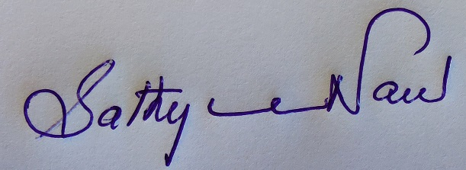

Signature or thumb impression of the subscriber

**Strike out whichever is not applicable.

Part B (EPS) (Para 18)
I hereby furnish below particulars of the members of my family who would be eligible to receive widow/children pension in the event of my death.

Sl. No. Name of the family Address Date of Birth Relationship with the member
member

1 2 3 4 5
SOUNDARYAA S B6,
SATHYANAND
NIKETAN,
SHIVA NAGAR,
KALAPATTI,
COIMBATORE 641048
1

2

3

4

** Certified that I have no family, as defined in para 2(vii) of Employees’ Pension Scheme, 1995 and should I acquire a family hereafter I shall furnish particulars thereon in the above form.

I hereby nominate the following persons for receiving the monthly widow pension (admissible under para 16 2(a) (i) and (ii) in the event of my death without leaving any eligible family member for receiving Pension.

Name and Address of the Nominee Date of Birth Relationship with the member

1 2 3
1. SOUNDARYAA B 02/01/1992 WIFE
B6, SATHYANAND NIKETAN,
SHIVA NAGAR,
KALAPATTI,
COIMBATORE 641048

2.

3.

4.

Date:27/4/2022

Signature or thumb impression of the subscriber
**Strike out whichever is not applicable.

CERTIFICATE BY EMPLOYER

Certified that the above declaration and nomination has been signed/thumb impressed before me by Shri/Smt./Kumari________________________________________________________employed in my establishment after he/she has read the entries/the entries have been read over to him/her by me and got confirmed by him/her.

Place: ___________________

Date __________________
Signature of the Employer or other authorised
Officer of the establishment

Designation……………………………………….
Name and address of the Factory/Establishment

